Computer Peripherals and Interfacing
Mid Exam Preparation — Suggested Answers

Part A — Memory Devices (PDF-1): Definitions & Basics
Memory Cell: A memory cell is a device or circuit that stores a single bit (0 or 1). Example: a flip-flop, a charged capacitor, or one spot on a magnetic disk.
Memory Word: A memory word is a group of bits (cells) that together represent one instruction or one piece of data. Word size usually ranges from 8 to 64 bits.
Byte: A byte is always 8 bits. Word size can be written in bits or in bytes (8 bits = 1 byte).
Address: An address is a number that shows the location of a word in memory. Every word has a unique address. Addresses are always binary internally, though octal, hex, or decimal is used for convenience.
Access Time (tACC): Access time is the time needed to complete a read operation — the time between giving a new address and getting valid data at the output. It measures memory speed.
Capacity: Capacity tells how many bits a memory can store. "1K" means 1024.
Read Operation: Sensing the word stored at an address and sending it out. Also called a fetch operation.
Write Operation: Placing a new word into a memory location. Also called a store operation — it replaces the old word.

Volatile vs Non-volatile
Volatile memory needs power to keep data; data is lost when power goes off. Non-volatile memory keeps data even without power. Most semiconductor RAM is volatile; all magnetic memory and ROM are non-volatile.
"All information is lost when power is removed" -> True (for volatile memory).

RAM (Random-Access Memory)
In RAM, access time is the same no matter which address you read — physical location of the word does not affect read/write speed. Most semiconductor memories are RAM.

SAM vs RAM
In RAM, access time is constant for every address. In SAM (Sequential-Access Memory), access time is not constant — you must go through addresses one by one until you reach the desired one, so it is much slower. Example of SAM: magnetic tape.

RWM vs ROM
RWM (Read/Write Memory) can be read from and written into with equal ease. ROM (Read-Only Memory) is designed mainly for reading — it can be written (programmed) only once, usually at the factory, and after that only read operations happen.

Static vs Dynamic Memory
Static memory keeps data permanently as long as power is applied — no need to rewrite. Dynamic memory loses data even with power on, unless data is periodically rewritten (refresh operation).
"A dynamic memory will hold its data as long as power is applied" -> False (it needs periodic refreshing too).

Worked Examples (Capacity / Address Calculations)
Example 2.1 — Question: A certain semiconductor memory chip is specified as 2𝐾×8. How many words can be stored on this chip? What is the word size? How many total bits can this chip store?
- Words = 2K = 2 x 1024 = 2048 words
- Word size = 8 bits (1 byte)
- Total bits = 2048 x 8 = 16,384 bits

Example 2.2 — Compare 5M x 8 vs 1M x 16
- 5M x 8 = 5 x 1,048,576 x 8 = 41,943,040 bits
- 1M x 16 = 1,048,576 x 16 = 16,777,216 bits
- Conclusion: the 5M x 8 memory stores more bits.
Example 3.1 — A 4K x 8 memory
- (a) 8 data input lines and 8 data output lines (word size = 8)
- (b) 4K = 4096 words; 2^12 = 4096, so 12 address lines are required
- (c) Capacity in bytes = 4096 bytes
Review Question — 8K x 16 memory
- Bits per word = 16
- Words stored = 8K = 8 x 1024 = 8192
- Total memory cells = 8192 x 16 = 131,072 cells
Review Question — 16K x 12 memory (page 31)
- Words = 16K = 16,384
- Address lines needed: 2^14 = 16,384, so 14 address lines
- Data input lines = 12, data output lines = 12 (word size = 12)

Figure — Sample Memory Illustration (32 x 4 Memory)
This is the reference diagram to study for the "draw a memory block diagram" question. A larger memory (e.g. 32K x 8) follows the same structure with more address and data lines.
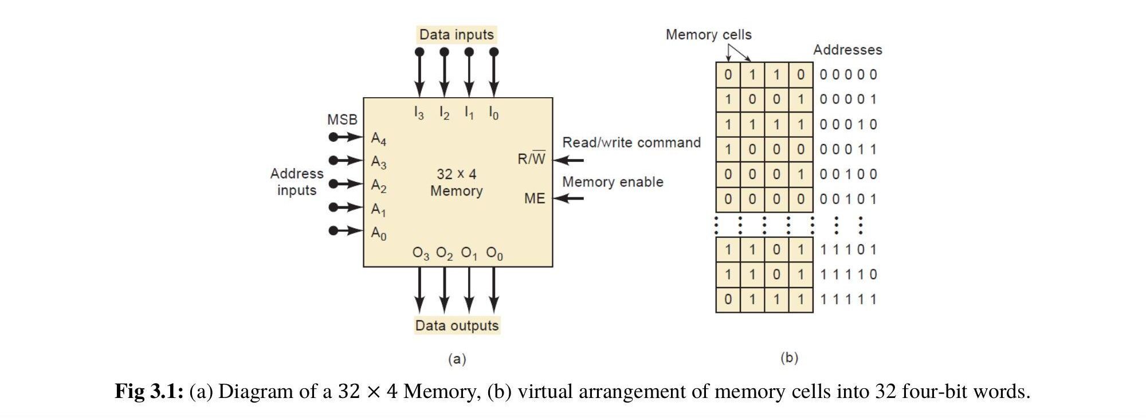
Fig 3.1: Diagram of a 32 x 4 Memory and virtual arrangement of memory cells (source: course PDF-1, p.29)

R/W and Memory Enable (page 32)
R/W input: Tells the memory chip whether to do a read (usually R/W = 1) or a write (R/W = 0) operation.
Memory Enable (ME) input: Activates/enables the chip so it can respond to address and control signals. If ME is not active, the memory ignores all inputs (output stays disabled / high-impedance).

Bus Connections (page 34-36)
Three groups of lines connect the CPU and memory:
- Address bus — unidirectional, carries address from CPU to memory, selects a location.
- Data bus — bidirectional, carries data both ways between CPU and memory.
- Control bus — unidirectional (CPU to memory), carries signals like Read/Write to control the operation.

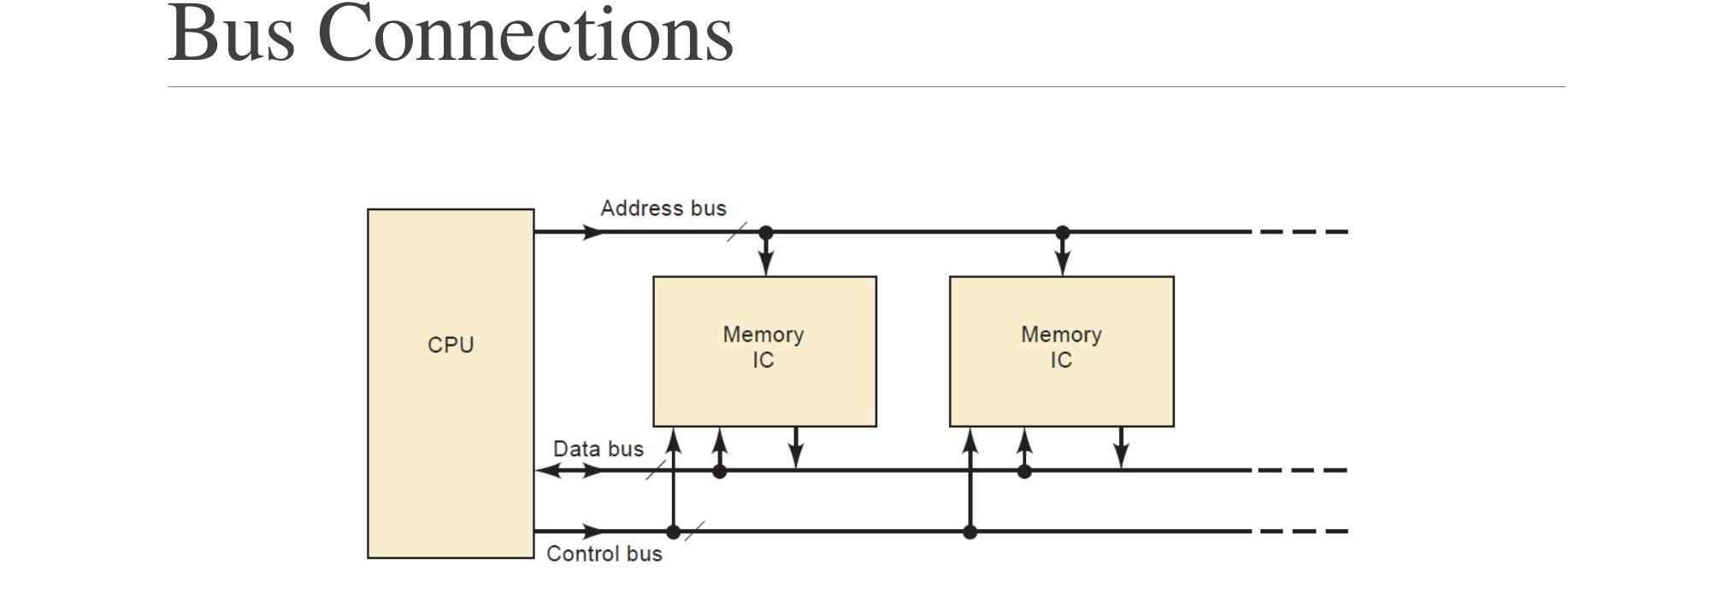
Fig 4.1: Three groups of lines (buses) connect the main memory ICs to the CPU (source: course PDF-1, p.34)
Steps when CPU reads from memory:
- 1. CPU places the address on the address bus.
- 2. CPU activates the control bus with a Read signal.
- 3. Selected memory location places its data on the data bus.
- 4. CPU reads that data from the data bus.
Steps when CPU writes to memory:
- 1. CPU places the address on the address bus.
- 2. CPU places the data to be stored on the data bus.
- 3. CPU activates the control bus with a Write signal.
- 4. Memory stores the data at the selected address.

Part B — Read-Only Memory (PDF-2)

What is ROM?
ROM (Read-Only Memory) is a semiconductor memory that holds data which is permanent or rarely changed. Normally no new data can be written during operation — data can only be read. Some ROM types can be programmed once (at the factory); others can be erased and reprogrammed. All ROM is non-volatile.

Review Questions (page 4)
- "All ROMs are non-volatile" -> True.
- Procedure to read from ROM: (1) apply the correct address to the address inputs, (2) activate the control input (chip select, CS). Then the stored data appears at the output.
- Programming / burning-in: the process of entering (writing) data permanently into a ROM. For most ROM types this happens at the factory; some types can be programmed by the user with special equipment.

ROM Block Diagram

ROM Architecture (register array, decoders, output buffer)
- Register array — stores the programmed data; arranged in rows and columns like a matrix. Each register holds one word.
- Row / column decoders — the address bits are split into two parts: some bits go to a row decoder, others to a column decoder. Together they select exactly one register to activate.
- Output buffers — pass the selected register's data to the external output pins, only if chip select (CS) is active (LOW).
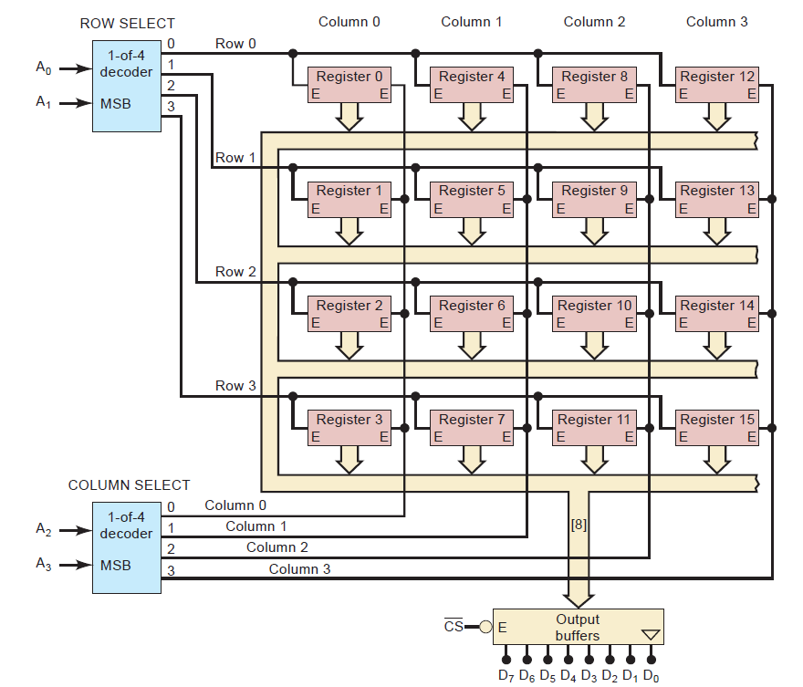
Fig 2.1: Architecture of a 16 x 8 ROM — each register stores one eight-bit word (source: course PDF-2, p.11)
Example 2.1 — Which register is enabled by address 1101?
- A3A2 = 11 -> activates Column 3
- A1A0 = 01 -> activates Row 1
- Answer: register at Row 1, Column 3 is selected.
Example 2.2 — What address enables register 7?
- Register 7 sits at Row 3, Column 1.
- Row 3 -> A1A0 = 11, Column 1 -> A3A2 = 01
- Answer: Address = A3A2A1A0 = 0111
Example 2.3 — ROM storing 4K bytes, square array
- 4K bytes = 4096 eight-bit words; 4096 = 64 x 64
- So the array has 64 rows x 64 columns.
- Needs a 1-of-64 row decoder (6 address bits) and a 1-of-64 column decoder (6 address bits).
- Total address inputs = 6 + 6 = 12 lines (since 2^12 = 4096).

ROM Timing (page 20)
When a new address is applied, CS goes active, then after access time (tACC) and output-enable time (tOE), valid data appears at the output. Before that, the output stays in high-impedance (Hi-Z) state.
Fig 3.1: Typical timing for a ROM read operation (source: course PDF-2, p.20)

Part C — Bus and Types of Bus (PDF-3)
Bus: A bus is a communication system that transfers data between components inside a computer, or between computers. All peripherals connect to the microprocessor through the bus.
System Bus: A system bus is a single bus that connects the major parts of a computer system. It has three types.
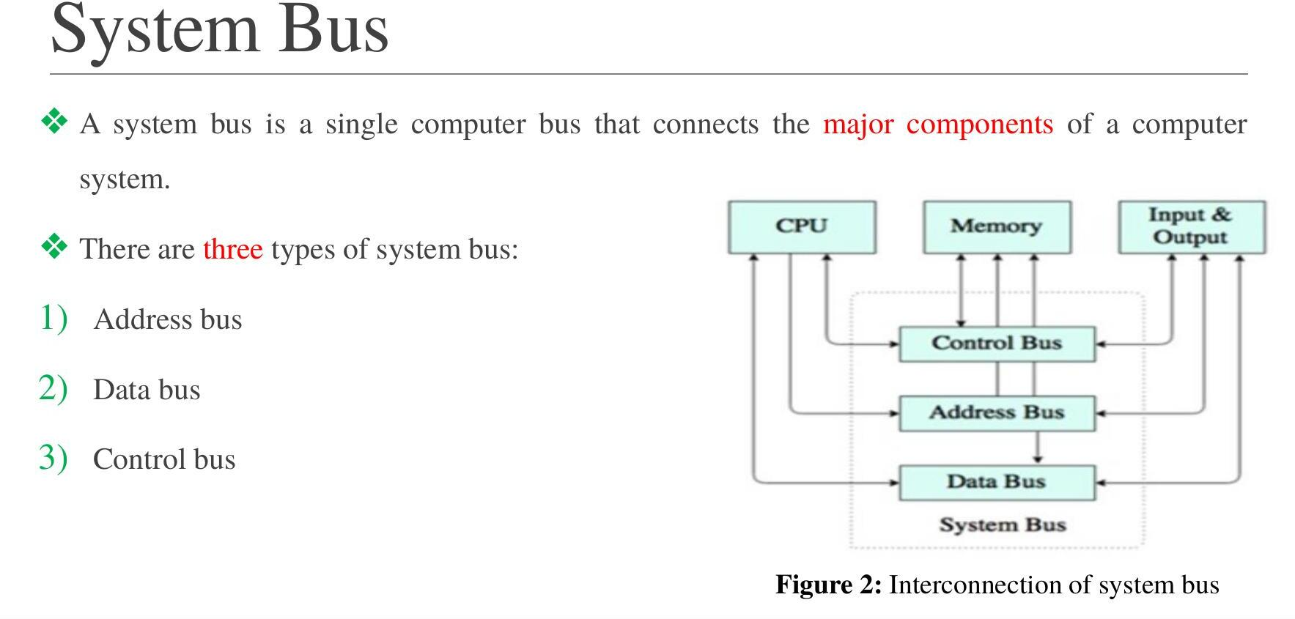
Fig 2: Interconnection of system bus (source: course PDF-3, p.4)
1. Address Bus
- Carries address only.
- Unidirectional — flows only from microprocessor to memory/I-O (out of the microprocessor).
2. Data Bus
- Carries data only.
- Bidirectional — data flows both ways: microprocessor <-> memory/I-O.
3. Control Bus
- Carries timing and control signals to control peripherals.
- Unidirectional.
- Example signals: Memory read, Memory write, I/O read, I/O write, Opcode fetch.

Peripherals
A peripheral is an auxiliary device connected to the computer to put information in or take information out. Examples: keyboard, mouse, graphics card, microphone, speaker, scanner, printer.

Microprocessor Interfacing
- Computer Interfacing = the art of connecting computers and peripherals.
- Microprocessor Interfacing = connecting a microprocessor with various peripherals to perform operations and get output.
- Two main types: (1) Memory Interfacing — used when the microprocessor needs to access memory frequently for read/write. (2) I/O Interfacing — connecting input/output devices with the microprocessor.

Class Test Style Questions (likely to repeat in Mid)
Q1. What is RAM? Draw a block diagram of a 32K x 8 RAM.
RAM (Random-Access Memory) is a type of memory where the access time is the same for every address — physical location of the word does not affect read/write speed. Most semiconductor memories are RAM.
For the diagram: a 32K x 8 RAM needs:
- 32K = 2^15 words -> 15 address lines (A0-A14)
- Word size = 8 -> 8 data input lines, 8 data output lines
- Plus an R/W control line and a Memory Enable (ME) line
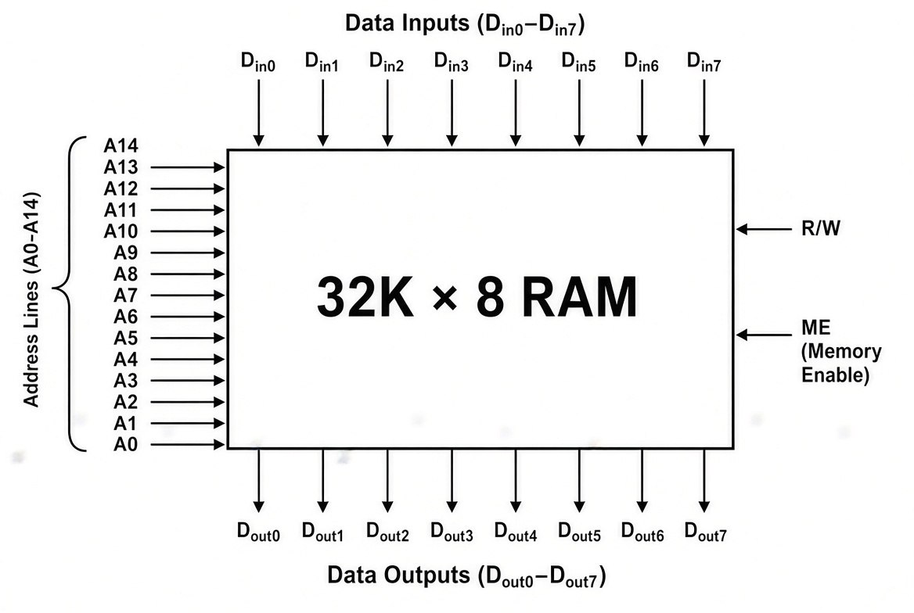
Use the same block structure as Fig 3.1 above (address inputs on the left, data inputs/outputs on top/bottom, R/W and ME control lines on the right) — just relabel it for 32K x 8 (15 address lines, 8 data lines each way).
Q2. A memory has capacity 16K x 8. Find bits per word, words stored, total memory cells, and address lines.
- Bits per word = 8
- Words stored = 16K = 16 x 1024 = 16,384
- Total memory cells = 16,384 x 8 = 131,072 cells
- Address lines: 2^14 = 16,384, so 14 address lines

Quick Tip
Almost every set has one capacity/address calculation question, one definition/true-false question, and one diagram/bus-explanation question. Practice writing the memory calculation steps clearly (K value -> total words -> 2^n = words -> n = address lines) since examiners check the working, not just the final number.

Computer Memories(PDF-1, modules-1)
A computer system normally uses highspeed main memory and slower external auxiliary memory.

